
How can tertiary education deliver better value to the economy?

The Tertiary Education Occasional Papers provide short reports on research, analysis and statistics relating to tertiary education in New Zealand. These papers include short original works and summaries of published research and analysis.
Author
David Earle, Senior Analyst
Email: david.earle@minedu.govt.nz
Telephone: 04-463 8524
Acknowledgements
The author gratefully acknowledges the opportunity provided by the Association of Tertiary Education Management to present this paper originally at their conference in Auckland in July 2010. The author also acknowledges the comments provided on this version of the paper by Colin Webb (Tertiary Education Commission), David Patterson (Department of Labour) and Peter Winsley (Ministry of Economic Development).
All views expressed in this paper, and any remaining errors or omissions, remain the responsibility of the author.
Published by
Tertiary Sector Performance Analysis and Reporting
Strategy and System Performance
MINISTRY OF EDUCATION
© Crown Copyright
All rights reserved.
All enquiries should be made to the publisher.
This paper is available from the Ministry of Education’s Education Counts website:
www.educationcounts.govt.nz
December 2010
ISSN 1179-5026 (online)
How can tertiary education deliver better value to the economy?

key findings

Education is associated with long-term improvements in economic performance. The link between education and economic performance can be conceived of in three broad ways:
- improving the overall knowledge and skills of the population
- providing capacity for innovation
- transfer of new knowledge and ideas.
Research indicates that improved school-level education leads to improved economic performance (more so than the other way around). However, it is the quality of learning, rather than the amount of time spent in education, that is most important. The direction of the relationship for tertiary education is less clear.
New Zealand is well educated compared with other developed countries. It has a high, and increasing, proportion of people with tertiary qualifications and a reasonably high proportion with good literacy and numeracy skills. However, New Zealand’s labour productivity has been low relative to the level of educational attainment. Reasons for the recent low labour productivity in New Zealand include:
- the rapid expansion of the workforce from 1999 to 2007, which brought in lower skilled workers
- a high reliance on skilled migrants, many of whom have English as an additional language, and take time to adjust to the New Zealand workforce
- a relatively high proportion of the workforce in low value-added industries and low capital intensity
- small size and distance from major economic centres.
There is little evidence of general qualifications shortages in New Zealand, although there are shortages in some specialist areas. Both demand for and supply of qualifications is increasing, with demand staying slightly ahead of supply. The key issue is the quality of education people receive, whether it equips them with the skills they need and is relevant to their future life and work.
While the tertiary education system does have a direct link to business innovation, the indirect links are more widespread. These include dissemination of knowledge through publications and conferences and the knowledge and skills graduates bring to their jobs. The major barrier to innovation for firms is resources and skills, rather than a lack of information. Therefore, one of the major contributions tertiary education can make to innovation is in the preparation and training of graduates.
Overall, tertiary education provides a small, but important, contribution to driving economic growth. The quality of the skills graduates bring to their work is more important than simply the number of people in the workforce holding qualifications. These skills are most productive where businesses have the capital, management skills, scale and links to international markets to support innovation and productivity gains.

Introduction
This paper asks how tertiary education can deliver better value to the economy. It is based on a presentation given at the New Zealand conference of the Association of Tertiary Education Management in Auckland in July 2010.
The paper begins with a review of the evidence for the influence of education on economic performance. It then looks at where New Zealand is placed with regard to tertiary education attainment and economic performance. This is followed by a discussion of the issue of productivity, and why productivity is such a large part of the debate. This leads into the question of whether there is unmet demand for tertiary qualified people in employment. And finally, the paper touches on the issue of innovation. It finishes with a discussion of what this means for tertiary education.

What is the link between education and economic performance?
It is well established that improvements in education are associated with long-term improvements in economic performance. There are three broad theories about how education influences economic performance:
- The basic human capital approach is that education improves the overall skills and abilities of the workforce, leading to greater productivity and improved ability to use existing technology, and thus contributing to economic growth.
- The innovation approach links education to improving the capacity of the economy to develop of new ideas and technologies.
- An extension of this is the knowledge transfer approach, which sees education as a means of spreading the knowledge needed to apply new ideas and make use of new technologies (OECD, 2010a).
However, there is an important question as whether there is a causal link between education and economic performance, and if so, in what direction. It may be that the two are associated, but not causally linked. It also could be that better economic performance leads to an increase in educational participation and achievement. Or it could be that having more people with education leads to improved economic performance.
In general, education and economic performance are likely to be interlinked. Having a more educated workforce enables firms to take advantage of new economic opportunities, leading to improved performance. Also, economic growth can lead to greater national and personal wealth, which increases the resources available and opportunities for education.
Economic analysis shows that on the whole, improvements in school-level education lead to improvements in economic performance, and more so than the other way around. Analyses using international cognitive tests have shown that it is improvements in cognitive skills, rather than years of schooling, which have a strong influence on economic growth. The amount of schooling undertaken is not related to growth, unless it also results in improved cognitive skills. Therefore, the quality of education is very important (OECD, 2010a).
The evidence about the relationship between tertiary education and economic performance is less clear. Long-run analysis of the New Zealand economy has shown that increased tertiary education is related to economic performance. Razzak and Timmins (2010) showed that increases in the proportion of employees with bachelors degrees and above are highly correlated to increases in the average gross domestic product per person. However, it is not clear if the growing economy attracted more degree-qualified workers or the increase in degree-qualified workers stimulated economic growth, or a combination of both.

New Zealand’s tertiary education and skill attainment
New Zealand sits near the top of the Organisation for Economic Cooperation and Development (OECD) countries in terms of tertiary attainment and shows continuing improvement in tertiary educational achievement. In 2008, 40% of New Zealanders aged 25 to 64 had achieved a tertiary qualification at diploma level or above. This was well above the OECD average of 28%.
As shown in Figure 1 below, almost half of New Zealanders aged 25 to 35 years have a tertiary qualification, placing New Zealand near the top of OECD countries, and ahead of Australia and the Scandinavian countries. Comparing this rate with the rate for 55- to 64-year-olds provides a picture of the generational change in education achievement. About a third of New Zealanders aged 55 to 64 have a tertiary qualification. This suggests improvements in tertiary education achievement over time.
Figure 1
Proportion of 25 to 34 year olds and 55 to 64 year olds with a tertiary qualification
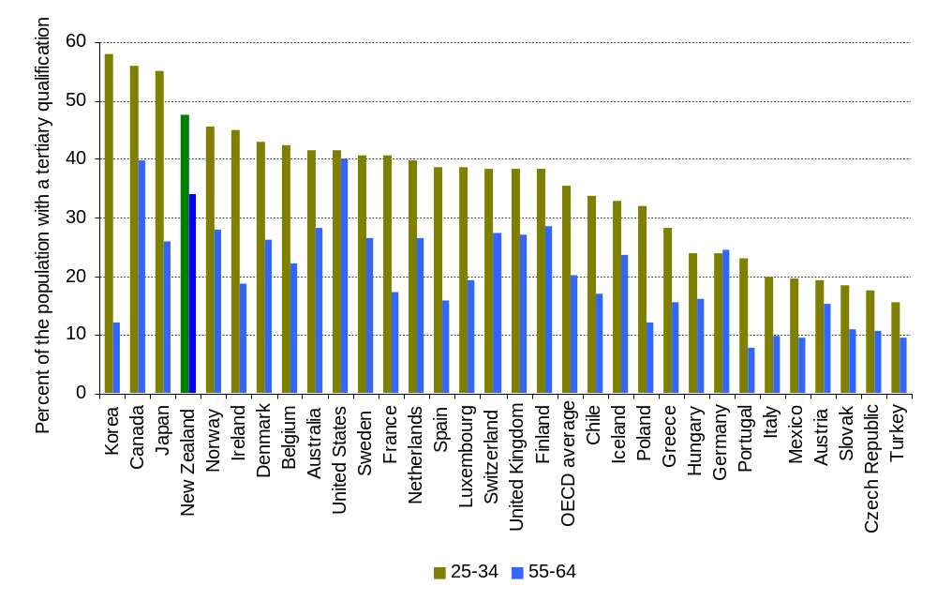
Source: OECD (2010b)
Note: Tertiary qualification is defined as diploma and above for purposes of international comparison.
The 2006 Adult Literacy and Life Skills (ALL) survey provides a more direct measure of adult skills. It directly assessed the literacy and numeracy skills of a sample of New Zealanders aged 15 to 64. Literacy and numeracy skills were assessed across four domains. One of the domains, document literacy, provides a measure of the ability of people to use and interpret a mixture of text and graphic material. Skills are reported from the ALL survey in five levels.
Figure 2 below shows the proportion of the population with moderate to high document literacy in the countries that participated in the ALL survey. Level 3 is “deemed as a minimum for persons to understand and use information contained in the increasingly difficult texts and tasks that characterise the emerging knowledge society and information economy” (Statistics Canada and OECD, 2005).
In the 25- to 54-year-old population, New Zealand has about 60% of the population with high literacy skills. The New Zealand age profile is notable for evenness of the distribution across age groups. In the 55- to 65-year-old population, New Zealand has the highest proportion of people with high document literacy skills of any of the participating countries.
Norway, Canada and Australia have a higher proportion of people aged 25 to 35 with high literacy skills than New Zealand. The New Zealand results in this age group are affected by the large proportion of recent immigrants with English as an additional language, as discussed later in the paper. The United States has lower skills across all age groups.
Figure 2
Proportion of 26 to 45 year olds and 46 to 65 year olds with moderate to high document literacy
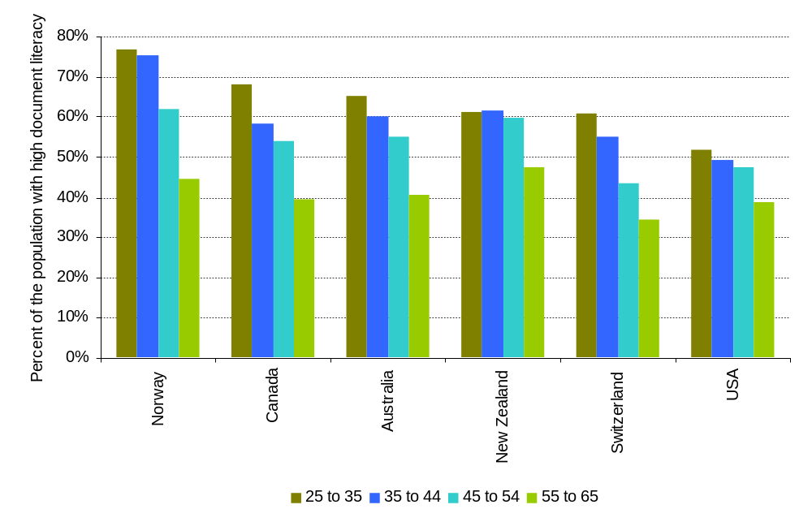
Sources: Adult Literacy and Life Skills Survey 2003-2006 International Dataset and Australian Bureau of Statistics (2008).
Note: Moderate to high document literacy is defined as level 3 and above

Which matters more – qualifications or skills?
In general, literacy and numeracy skills and qualification attainment are related. However, some people have low or no qualifications and adequate literacy and numeracy, and conversely, some people have tertiary qualifications and low literacy and numeracy (Ministry of Education 2009, Smyth and Lane 2009).
The evidence from the ALL Survey suggests that both skills and qualifications matter. Figure 3 below looks at the relationship between document literacy and hourly wages given different levels of qualification. While literacy skills are only part of the skill sets required for jobs, they provide indicators of the difference in value put on skills versus qualifications. Hourly wages provide a rough proxy for the value of work undertaken.
Figure 3
Relationship of document literacy to hourly wages by qualification level
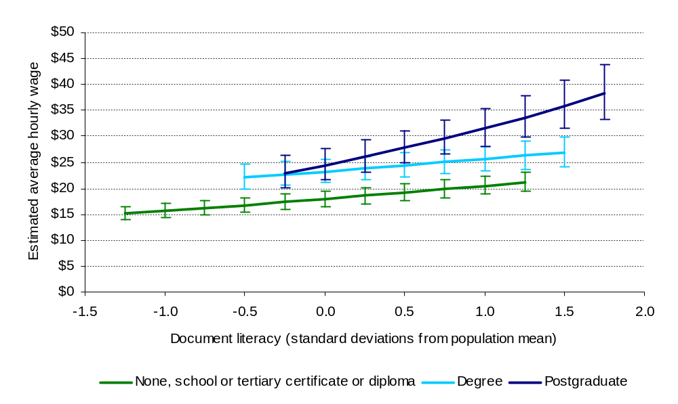
Source: Earle (2010b).
Note: Results are from a log-liner model of hourly wages. The reference group is males, aged 30, with English as a first language. The lines show the distribution from the 10th to 90th percentile fore each qualification level.
The relationship for people with no qualifications through to tertiary certificates and diplomas is very similar. There were differences within this group by qualification level – but not enough to be statistically significant given the sample size. So, on the whole for this group, wages increase steadily with skills, irrespective of qualifications.
However, having a bachelors degree relates to a step increase in wages, even for people with lower levels of document literacy. So here, having the qualification has more effect on wages than higher skills. For postgraduate qualifications, there is a much greater return on higher skills. This is largely because people with these qualifications are at the top of the qualifications requirements for their job. In their case, the skills they bring to the job are reflected in their wages.
From this it can be seen that qualifications provide entry requirements for occupations and jobs, while skills differentiate people in terms of their performance.

What economic value does New Zealand get from its qualifications and skills?
The previous section established that New Zealand is reasonably well placed among its peers for both the amount of tertiary education and the overall skills of the population. But do we get the full economic value from our skills and qualifications?
Figure 4 below compares the proportion of 25- to 64-year-olds with tertiary qualifications on the horizontal axis with gross domestic product (GDP) per capita on the vertical axis. GDP per capita provides a general measure of economic performance and wellbeing. The latter has been averaged out over 10 years to smooth out the varying effects of the recession.
Most OECD countries have been plotted on the chart. The line shows the average relationship between tertiary education attainment and GDP per capita. It shows that there is a moderately strong relationship between tertiary education levels and GDP per capita. New Zealand is well to the right on tertiary education, with a high proportion of the population with tertiary qualifications. However, we are well below the predicted line in terms of GDP per capita.
This shows that given our considerable investment in tertiary education, we are not performing as well economically as might be expected. So then, why are we not getting more economic value out of our tertiary-educated workforce?
Figure 4
Comparison of tertiary education attainment and average GDP per capita
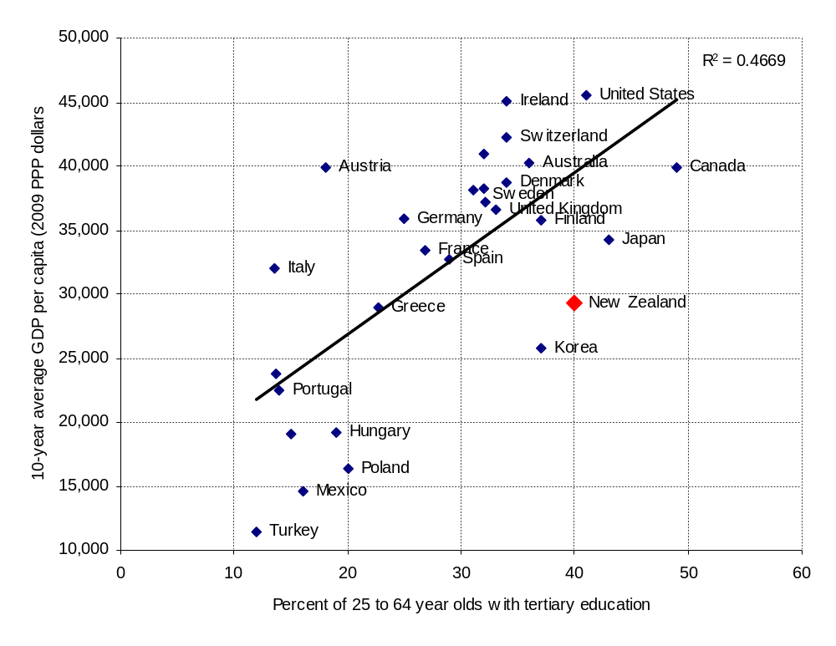
Source: OECD, Education at Glance 2009 and The Conference Board and Gronignen Growth and Development Centre
Note: Tertiary qualification is defined as diploma and above for purposes of international comparison.

Understanding productivity
A key to understanding the economic value of skills in the workforce is understanding productivity. In proceeding with this discussion, some clarity around what productivity is is useful. It is a deceptively simple statistic, with a lot of information packed into it.
Productivity is not a measure of production. It is a measure of efficiency. It measures the volume of what is produced per unit of input. Inputs are capital investment, labour, and the interaction between both.
Labour productivity measures how much is produced per unit of labour. Capital productivity measures how much is produced per unit of capital. Multi-factor productivity measures changes that are not directly attributed to either capital or labour, which can be ascribed to changes such as the application of technology to improve production, as well as measurement error. None of these measures are “pure” in themselves. For example, labour productivity may change due to how well capital assets and technology are utilised, without any change in the effort or capability of workers (Statistics New Zealand, 2010b).
Output volumes for productivity calculation are measured using a constant-price approach to
GDP. This method fixes the price of the output at a base year, so that changes in volume can be tracked independent of fluctuations in market price. However, if the composition of the outputs changes towards higher or lower value products, this may be reflected in the productivity measure. That is, a change from low value-add products to high value-add products could result in increased productivity if the inputs required to produce them remain the same.
Productivity matters because it can drive growth in the quantity and value of national production. This can lead to improved incomes and economic wellbeing and improved international competitive advantage.
However, productivity is not what firms and employees focus on most. For firms, the key measure is profitability and for employees it is wages. Changes in productivity may or may not influence these directly, or even at all. For example, firms can raise their profits by taking on more, less productive workers, in order to meet growing demand. This results in a drop in productivity, while increasing profitability. Wages broadly reflect the productive value placed on workers. However, changes in wages do not necessarily match changes in the value of what workers produce.

Why is New Zealand’s productivity so low?
As shown before, New Zealand has had a substantial growth in the workforce with tertiary qualifications. There is evidence that a more qualified workforce is linked to higher productivity. Figure 4 above shows the relationship of educational attainment to GDP per capita. A very similar graph can be drawn using labour productivity measures, with New Zealand in the same position of high education and low labour productivity (see Earle 2010a).
This raises the question of why New Zealand’s labour productivity is relatively low for the proportion of the workforce with tertiary qualifications. A number of reasons contributed to this in recent years.
From 1999 to 2007, the expanding economy led to an expanding workforce. At the same time, high labour demand in Australia led to net emigration from New Zealand to Australia. Many of the additional workers entering the New Zealand workforce had lower qualifications and less work experience. This resulted in reduced average production per worker (Earle 2010).
New Zealand had a high reliance on skilled immigration between 2000 and 2007 to fill workforce gaps. In 2006, 20% of degree holders and 30% of postgraduates in employment in New Zealand had arrived within last 10 years – of these, 60 percent have English as aan additional language (Earle 2009b). It takes time for migrants to adjust to a new country and become fully productive. Recent research suggests it takes ten to twenty years for immigrants with bachelors degrees to move into occupations that match their educational levels (Poot and Stillman, 2010). Having English as an additional language is a further barrier to being employed at full potential in New Zealand, even for people who have good English-based literacy (Earle 2009b and 2010a).
The structure of the New Zealand economy also contributes to low productivity. New Zealand has a relatively large proportion of the workforce in low value-added sectors, such as agriculture (Mason and Osborne, 2007). New Zealand also has relatively low capital intensity, compared to its trading partners. Private investment in research and development is also linked to productivity, and is low in New Zealand (Earle, 2010a).
Finally, economic geography works against New Zealand. Economic geographers have shown that over half the gap in labour productivity between New Zealand and the OECD can be attributed to geography. The small size of the economy further increases the gap. The global trend is towards the concentration of capital and skilled labour in major cities. This has the effect of encouraging the outflow of both towards Australian cities (McCann 2009). Hendy (2009) found that innovation, as measured by number of patents per capita, is strongly related to city size. He showed that New Zealand cities perform as well as similar sized Australian cities on this measure. However, we do not match the rate of the large Australian cities.

Does New Zealand have a skills or qualification shortage?
All of these factors suggest that the attainment and supply of qualifications and skills are just one part of a much bigger economic and global picture. However, the question of whether New Zealand has sufficient people with skills and qualifications in the workforce is still important.
There is little evidence for wide-spread qualification shortages. Analyses of the supply and demand for trade, technical and professional qualifications only found a few areas where there was strong evidence for qualification shortages (Earle 2009a).
The Department of Labour forecasts indicate there will be limited overall employment growth over the next decade. Growth is likely to be stronger in the skilled occupations, leading to greater demand for higher-skilled workers in the workforce. This will be matched by continued growth in the number of tertiary-qualified workers (Department of Labour, 2010a, 2010b and 2010c). Research in 2008 found that the increase in demand for tertiary qualified workers was running just slightly ahead of the increase in supply (Razzak and Timmins, 2008)
There has been a lot of discussion over the last five to ten years about skill shortages. However, skill shortages are often confounded by labour shortages. That is: has the demand for skilled labour exceeded the supply? Or are we genuinely short of specific skills?
Figure 5 below shows that the demand for skilled labour closely follows the economic cycle. This means that recent skilled labour shortages have been closely linked to high economic growth rates. The question for tertiary education is whether we are meeting the long term demand across the cycles – and providing the skills that are relevant to changing work demands.
Figure 5
Difficulty of finding skilled and unskilled labour compared with economic growth in New Zealand
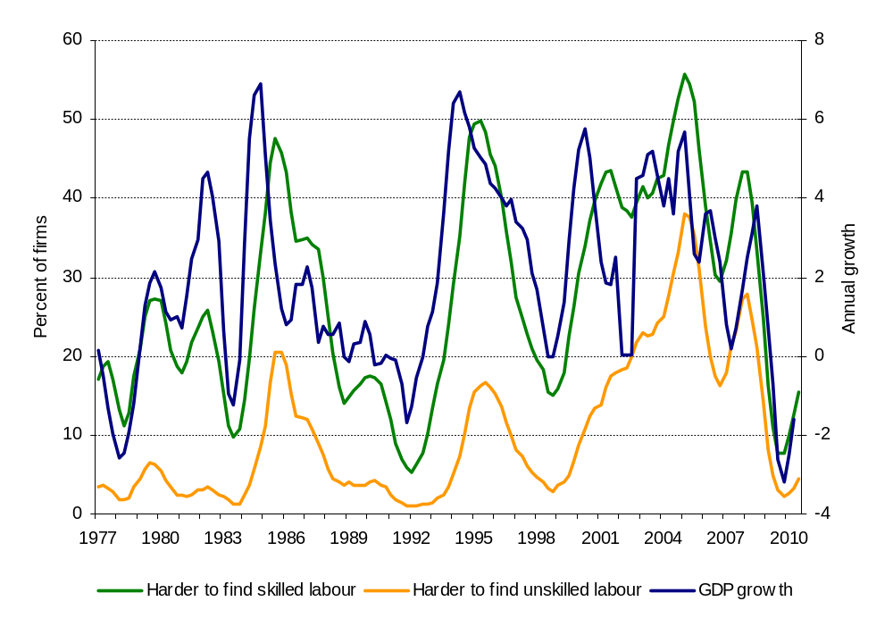
Source: NZIER (2010)
Note: Figures have been transformed to an annual rolling average to smooth out seasonal variation.

Where does innovation come in?
Going back to the theories about how education influences economic growth, we have largely discussed education in terms of its contribution of skills and abilities to the workforce. That is, the human capital theory. However, theories suggest that more there is more to it than that, and that innovation and knowledge transfer play important roles.
Innovation is important because it can provide a step change in economic output. Its effect on productivity is to reduce the amount of effort to produce the same volume of outputs and/or, more importantly, raise the volume of outputs being produced for the same amount of effort. It can also result in shifts toward higher value-added products for the same or similar amount of investment.
Figure 6
Sources of information for firms with innovation activity
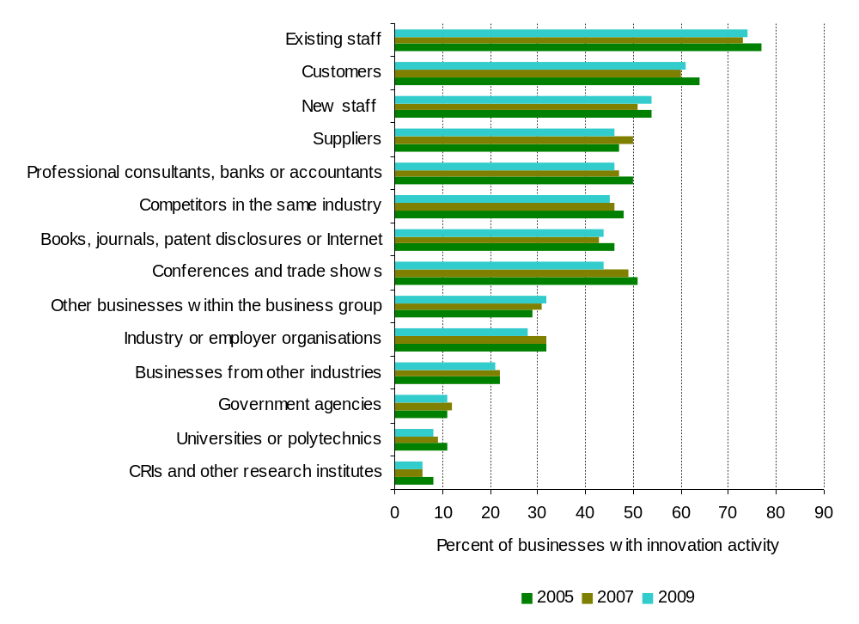
Source: Statistics New Zealand (2010a)
Figure 6 above shows the sources of information for businesses that have innovation activity. It shows a consistent pattern over the five-year period of the surveys. Less than 10% of businesses source their information directly from universities and polytechnics. This is not to say that these direct links are unimportant or insignificant. Rather, they are not widespread across businesses.
Information from other businesses is a more widespread source of information for innovation than universities and polytechnics. This may include some spill-over from those working directly with the tertiary sector. The next largest area is conferences and published material. This is an important area where the tertiary education system makes a contribution.
However, at the top of the list are staff, including new staff, and customers. So the most widespread influence of tertiary education on innovation is through the education of students and the skills and ideas they take with them into employment.
It is also interesting to look at the barriers to innovation.
Figure 7
Factors hampering innovation in business to a high degree
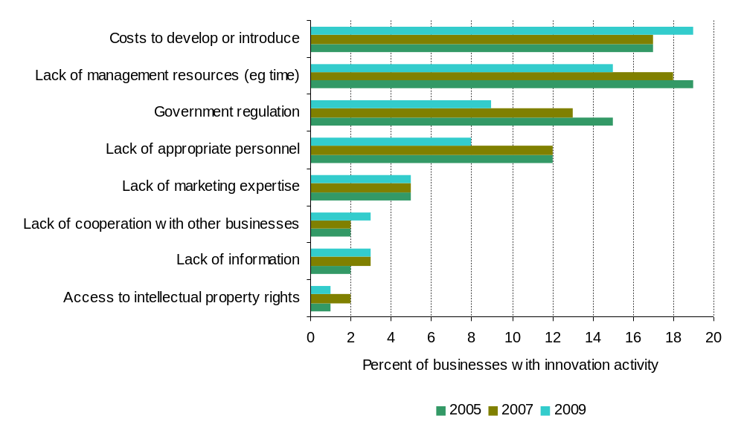
Source: Statistics New Zealand (2010a)
Figure 7 above looks the factors reported by businesses as having hampered innovation to a high degree. Lack of information is relatively infrequently reported as a factor hampering innovation. The most frequent barrier is the cost to develop or introduce the innovation. This is closely followed by lack of management resource and lack of appropriate personnel. In reality, it is probably the combination of lack of resources (time and money) and skills (technical and managerial) which is the greatest barrier to innovation.
Research commissioned by the Ministry of Economic Development rounds the picture off. The research looked at what characterised high value-added firms and medium value-added firms. These were firms operating in the same market sector and assessed according to their labour productivity relative to their industry. The key finding was that medium value-added firms focused on the production process and the skills of their technical and trade employees. While high value firms did so as well, they also focused on the value of their products and customer requirements and the business skills of a few, professional core employees (Kaye-Blake, et al, 2010).

So what does this mean for tertiary education?
It is clear that New Zealand does have a well-educated and skilled workforce. While the demand for education and skills will continue to increase, the country is likely to keep up with the overall demand, with some areas requiring more attention than others.
However, the New Zealand economy doesn’t perform as well as may be expected for its level of tertiary qualifications. There are a number of reasons for this, including recent expansion of the workforce, reliance on skilled migration, low capital intensity and the small size and relative isolation of the country. The role of skills and qualifications is an important, but relatively small part of the overall picture.
What matters most in tertiary education is the quality and relevance of the skills and knowledge that people gain. This is more important than increasing the number of people with qualifications alone.
The main avenue for raising economic performance is through innovation and increasing the returns to innovation through scale and links to international markets. The main barrier to innovation is availability of resources and skills, rather than lack of information. Small scale and poor linkages to international markets also dampen innovation rates. Tertiary education contributes most widely to innovation through the skills and knowledge that graduates bring to the workplace. Businesses also need to make use of these skills to focus on the value they are adding for customers, rather than just focusing on technical quality.
In conclusion, continuing to do what we are doing is good, but not good enough. If tertiary education is to deliver better value to the economy, then the focus needs to be on the value of what is being delivered. In most areas, this is not about more graduates, but rather graduates who are better prepared to contribute to the economy and with the skills to add value to their jobs. These skills are most productive where businesses have the capital, management skills, scale and links to international markets to support innovation and productivity gains.

References:
Australian Bureau of Statistics (2008) Adult Literacy and Life Skills Survey, Summary Results, Canberra: Australian Bureau of Statistics.
Department of Labour (2010a) Skillsinsight: The changing demand for skills, Wellington: Department of Labour.
Department of Labour (2010b) Skillsinsight: Changing qualification levels, Wellington: Department of Labour.
Department of Labour (2010c) Skillsinsight: Future employment demand by major skill categories, Wellington: Department of Labour.
Earle, D (2009a) Advanced trade, technical and professional qualifications – trends in supply, Wellington: Ministry of Education.
Earle, D (2009b) The effect of first language and education on literacy, employment and income: An analysis from the Adult Literacy and Life Skills survey, Wellington: Ministry of Education.
Earle, D (2010a) Tertiary education, skills and productivity, Tertiary education occassional paper 2010/01, Wellington: Ministry of Education.
Earle, D (2010b) The labour market outcomes of skills and qualifications, Tertiary education occasional paper 2010/05, Wellington: Ministry of Education.
Hendy, S (2009) “Patents: Australia vs New Zealand”, on A measure of science,
http://sciblogs.co.nz/a-measure-of-science/2009/11/02/patents-australia-vs-new-zealand/.
Kaye-Blake, W, Flagler B and Campbell R (2010) “Business strategies and employment decisions: interviews with New Zealand firms”, Paper to New Zealand Association of Economists Conference 2010.
McCann, P (2009) “Economic geography, globalisation and New Zealand’s productivity paradox”, New Zealand Economic Papers, 43 (3).
Mason G and Osborne M (2007) Productivity, capital intensity and labour quality at sector level in New Zealand and the UK. Working Paper 07/01, Wellington: The New Zealand Treasury.
Ministry of Education (2009) How well do qualifications predict literacy and numeracy? Wellington: Ministry of Education.
New Zealand Institute for Economic Research (2010) Quarterly Survey of Business Opinion, October 2010, Wellington: NZIER.
Organisation for Economic Co-operation and Development (2010a) The high cost of low educational performance: the long-run economic impact of improving PISA outcomes, Paris: OECD.
Organisation for Economic Co-operation and Development (2010b) Education at a glance 2010: OECD indicators, Paris: OECD.
Poot, J and Stillman S (2010) The importance of heterogeneity when examining immigrant education-occupation mismatch: evidence from New Zealand, Institute for Study of Labor (IZA), Discussion Paper No. 5211.
Razzak, WA and Timmins J (2008) “A macroeconomic perspective on skill shortages and skill premium in New Zealand”, Australian Economic Papers, 47(1).
Razzak, WA & Timmins J (2010) “Education and labour productivity in New Zealand”, Applied Economic Letters, 17(2).
Satherley, P, Lawes, E and Sok, S, (2008) The Adult Literacy and Life Skills (ALL) survey: overview and international comparisons, Wellington: Ministry of Education.
Statistics Canada and Organisation for Economic Co-operation and Development (2005) Learning a living: first results of the Adult Literacy and Life Skills survey, Ottawa and Paris: Statistics Canada and OECD.
Statistics New Zealand (2010a) Business Operations Survey: 2009, Wellington: Statistics New Zealand.
Statistics New Zealand (2010b) Productivity Statistics: 1978−2009, Hot Off the Press, Wellington: Statistics New Zealand.
Smyth, R and Lane C (2009) Skills and education: how well do educational qualifications measure skills? Wellington: Ministry of Education.
The Conference Board and Groningen Growth and Development Centre (2010) Total Economy Database (Jan 2010).

See Satherley, Lawes and Sok (2008) for further information on the survey.
Norway is left out because it has a large oil industry. Luxembourg has also been excluded as it is a largely urban economy.
A similar pattern is evident if tertiary qualifications are measured as bachelors degrees and above. The relationship is slightly weaker due to variations in the tertiary qualification systems across countries.

